June 1, 2022

Dad’s Club

Crimson Band Booster CluB

TABLE OF CONTENTS

CHAPTER ONE – GENERAL 3

Welcome and What We Do 3
Who is the Dad’s Club 3

CHAPTER TWO – Responsibilities 4

Construction Team 4
Cooking Dads 4
Drivers 6
Heavy Lifting Team 6

Annex A – Dad’s Club Talent Survey 7

Chapter 1

Welcome to the Dad’s Club!

Hello and welcome. I want to thank you for your interest in the Dad’s Club. You are the muscle behind the band! The Dad’s Club provides the ‘heavy lifting’ if you will, for the various programs within the overall band program.

- With guidance from the band directors, you plan, build, and move the props used in our Showcase performance as well as half-time football shows, when used.
- You help with the set-up and tear-down of the concession stand as well as do the grilling, frying, cooking as well as handling the beverages sold at the concession stand.
- You help with the transportation of band and color guard equipment to and from football games, Showcase, festivals, Mardi Gras and concerts when necessary, and finally,
- You help in the loading of the various trailers used in transporting the programs equipment.
The Dad’s Club is a team effort. There is a board member responsible for coordinating the needs of the Dad’s Club. That individual’s contact information is in the Band Parent’s Survival Guide. Please feel free to reach out and offer any support you may be able to provide. Remember, there is no job too small. Everyone’s help is appreciated more than can ever be expressed.

CBBC President

Who is the Dad’s Club?

Simply put, the Dad’s Club is made up of the fathers, uncles, grandparents, and other male adults with ties to the youth in the band program. Both the band and the color guard. We need people who like to build things. People who like to use tools and/or are creative and like to design. We need cooks, and drivers and guys who just want to help. There’s always something to do.

CHAPTER 2

RESPONSIBILITIES

Construction Team

Like to build things? Like to design things? Good with tools?

This group helps with prop design and assembly and various building projects that are necessary for the band program. They may also be needed to help with the placement and movement of these props during performances. A working knowledge of tools helps tremendously with this work. This group also puts in lots of hours in preparation for Showcase, as well as the festivals we compete in yearly. You will start the planning at band camp in July when the types of props needed are determined and start construction typically in August finishing them by the end of September. Once the competitions are completed and the props are no longer needed, they are broken down and either saved or disposed of. Some materials can be saved and reused for later performances.

Cooking Dads

Do you like to cook? Grill? Fry? Or are you there to help with the heavy lifting?

The ‘Cooking Dad’s are responsible for some of the set up as well as all the cooking at the concession stand.

Set Up

- Setup two (2) tables by fryers and Jambalaya pot.
- Setup one (1) table for grill and bring out bin labeled Grilling dads and several large and small warming trays.
- Set up canopy for grilling station.
- At 1PM begin the pot of Red Beans.
- Beverages (Concession Stand)

  - Remove all beverages from band shed and stack next to ice machine outside of concession stand. This includes beverages remaining from previous event.
  - Place four (4) cases of each, Coke and Dr. pepper in designated rolling tubs.
  - Place three (3) cases of each, Root Beer, Sprite and Diet Coke in designated rolling tubs.
  - Place six (6) cases of Dasani in large rolling red tub and two (2) cases of each Powerade in designated rolling red tub.
  - Place four (4) cases of Dasani and two (2) cases of each Powerade in individual crawfish sacks and place in designated chiller bins (large gray garbage cans lined with trash bags).
  - Place three (3) cases of each, Coke and Dr. Pepper in individual crawfish bags and place in designated chiller bins.

  - Place three (3) cases of Root Beer and two (2) cases of each, Diet Coke and Sprite in individual crawfish bags and place in designated chiller bins.

Cooking

- No Jambalaya will be cooked after one half (1/2) way through the third (3rd) quarter.
- No fries will be fried after the beginning of the fourth (4th) quarter.
- No burgers or hot dogs will be grilled after the beginning of the fourth (4th) quarter.
- No Oreos will be fried after the beginning of the fourth (4th) quarter.
- Remember when you are cooking your last batches to prepare enough to last through the game.

  - Grilling: Should begin grilling no later than 5PM. The hamburgers and hot dogs are cooked on the griddle and brought to the concession stand for prep to be sold. The hamburgers will be placed in a broth to be kept juicy and warm.
  - Frying: The following items will be fried.

    - French Fries
    - Oreos
    - Sausage
    - Chicken Tenders

The French fries and Oreos are cooked in one fryer and the chicken tenders and sausage is cooked in the second fryer. Every effort should be made to not cross fry because of taste transfer.

  - Cooking Jambalaya: Should begin cooking first pot of Jambalaya no later than 4PM. Be prepared to cook at least three (3) pots if serving red beans. Four (4) pots if not. The recipe for cooking Jambalaya is at Annex 6.
  - Cooking Red Beans: Red Beans need to be cooked by 3PM. Only cook one pot. The recipe
for cooking the red beans is at Annex 6.

Cleanup

- No Jambalaya will be cooked after one half (1/2) way through the third (3rd) quarter.
- No fries will be fried after the beginning of the fourth (4th) quarter.
- No burgers or hot dogs will be grilled after the beginning of the fourth (4th) quarter.
- No Oreos will be fried after the beginning of the fourth (4th) quarter.
- Remember when you are cooking your last batches to prepare enough to last through the game.
- The grilling station will be cleaned prior to putting away.

  - Ensure ‘Grilling Dad’s’ container is cleaned out.
  - If any additional supplies are needed before the next event, you should inform the BoH team leader. This includes propane.
  - Ensure grill is cleaned and greased before putting away.
  - Ensure propane is turned off.

- Ensure Jambalaya pot is cleaned prior to putting away.

  - Wash out pot with clean water, then burn out excess water.
  - Oil pot then place lid on it.
  - If any additional supplies are needed before the next event, you should inform the BoH team leader. This includes propane.

- Ensure fryers are wiped down prior to putting away.

  - If any additional supplies are needed before the next event, you should inform the BoH team leader. This includes propane.
  - The fryer baskets must be cleaned. They become quite messy. Especially the Oreos.

- All leftover beverages need to be placed back in their designated area in the shed.
- All tables and chairs need to be placed back their designated area in the shed.
- All propane tanks need to be placed back in their designated area in the shed.
- All utensils and containers used need to be cleaned before storing away. Aluminum food trays that have been used will be disposed of and NOT saved.
- All beverage chiller bins need to be emptied and stored upside down in the shed.

Drivers

We have an 18-wheel trailer, an enclosed cargo trailer, and several flatbed trailers that are used to carry equipment and materials wherever we go. We need volunteer drivers to pull these trailers. It is quite a production for the Crimson Band to go anywhere. There is a student loading crew that is responsible for loading and unloading the trailers every time they are used. In some instances, it is good to have some adults there helping with this process.

Heavy Lifting Team

As discussed in both cooking and driving there are always times when help is needed with heavy lifting, moving a lot of material, etc… that a few extra hands would always be appreciated. Please check the Calendar regularly to see if any opportunities exist that heavy lifting help may be needed.

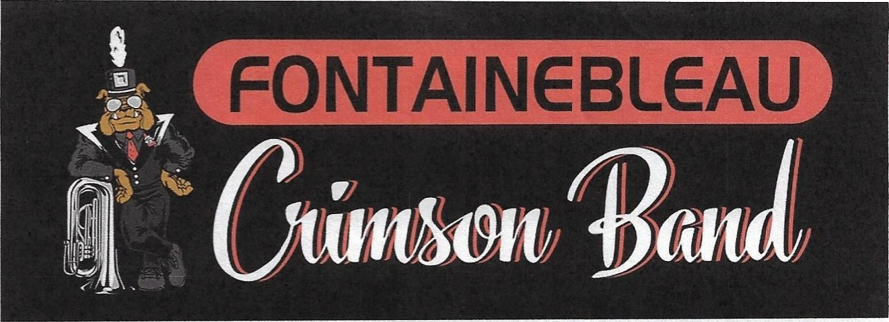
ANNEX A, Dad’s Club Talent Survey
Dad’s Club Talent Survey
Hello and welcome. I want to thank you for your interest in the Dad’s Club. You are the muscle behind the band! The Dad’s Club provides the ‘heavy lifting’ if you will, for the various programs within the overall band program.

- With guidance from the band directors, you plan, build, and move the props used in our Showcase performance as well as half-time football shows, when used.
- You help with the set-up and tear-down of the concession stand as well as do the grilling, frying, cooking as well as handling the beverages sold at the concession stand.
- You help with the transportation of band and color guard equipment to and from football games, Showcase, festivals, Mardi Gras, and concerts when necessary, and finally,
- You help in the loading of the various trailers used in transporting the programs equipment.

The Dad’s Club is a team effort. There is a board member responsible for coordinating the needs of the Dad’s Club. That individual’s contact information is in the Band Parent’s Survival Guide. Please feel free to reach out and offer any support you may be able to provide. Remember, there is no job too small. Everyone’s help is appreciated more than can ever be expressed.

We hope that you will enjoy being part of the Booster Club’s team and want you to know that whatever you can do to help will be appreciated.

CBBC President

By completing and submitting this survey, we want to help you uncover ways you can enjoy giving assistance. Please answer the following as completely as possible:

My interests/pastimes include:

_____ Food Service / Cooking _____ Driving _____ Parading _____ Construction / building

_____ Other Parent Groups (please specify): ____________________________________________________________

_____ Other Volunteer Work (please specify): ____________________________________________________________

My job, business, or profession might be of interest: ______________________________________________________

I am willing to help by providing behind-the-scenes support such as:

_________________________________________________________________________________________________

Name _______________________________________________________ Home phone _________________________

Street address ________________________________________________ Business phone _______________________

City __________________________ State ____ ZIP__________ E-mail address ________________________________

Shirt Size: ______________________________

Your willingness to help is appreciated. Please return this form in to Aaron Hotard or Patrick Smith.

